|  |
| --- |
| Circle Language Spec: Commands |

## Public Inactive Clause = Command Out Parameter

*Active* clauses, command calls and active command references in parent commands are always private, because you can not reference a sub-command (see the article *Sub-Commands Are Never Referenced*).

But *inactive* clauses *can* be referenced might be made public. If you make an inactive clause public, you will make it an Object Out parameter: an object produced by the command. A public inactive clause would be a command definition produced by another command. It would be an Object Out parameter, that is an executable object. That would work just fine.

### Diagram Notation

Active clauses, command calls and active command references in parent commands are always private, because you can not reference a sub-command (see the article *Sub-Commands Are Never Referenced*).

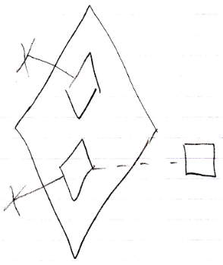

But *inactive* clauses *can* be referenced might be made public.

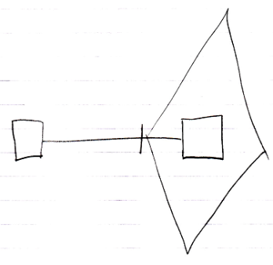

If you make an inactive clause public, you will make it an Object Out parameter: an object produced by the command.